

***HTML Essentials***

**Lab Guides**

|  |  |
| --- | --- |
| Document Code | 25e-BM/HR/HDCV/FSOFT |
| Version | 1.1 |
| Effective Date | 20/11/2012 |

**Hanoi, 04/2019**

RECORD OF CHANGES

|  |  |  |  |  |  |
| --- | --- | --- | --- | --- | --- |
| No | Effective Date | Change Description | Reason | Reviewer | Approver |
|  | 25/Jun/2018 | Create a new Lab | Create new | DieuNT1 | VinhNV |
|  | 01/May/2019 | Update Fsoft Template | Update | DieuNT1 | VinhNV |
|  |  |  |  |  |  |
|  |  |  |  |  |  |
|  |  |  |  |  |  |
|  |  |  |  |  |  |
|  |  |  |  |  |  |
|  |  |  |  |  |  |
|  |  |  |  |  |  |
|  |  |  |  |  |  |

Contents

Unit 1 - HTML Elements 4

Lab Objectives: 4

Problem Descriptions: 4

Guidelines: 4

Step 1: Create project structure 4

Step 2: Open project in Visual Studio Code 4

Step 3: Install Live-Server Extension 5

Step 4: Create index.html 5

Step 5: Add your first HTML element 6

Step 6: Add attributes to HTML element 6

Step 7: Adding some features to an HTML document 7

Step 8: Experiment with character encoding 8

Step 9: The description's use in search engines 8

Step 10: Verify output 9

|  |  |
| --- | --- |
|  | **CODE: HTML-E.S.L101**  **TYPE: Short**  **LOC: N/A**  **DURATION: 30 MINUTES** |

# Unit 1 - HTML Elements

## Lab Objectives:

* Understand web design guidelines and process which you can apply to real world web projects
* Understand the syntax of HTML Element

## Problem Descriptions:

## Guidelines:

Step 1: Create project structure

* Create a new folder called **HTML-E.S.L101**

Step 2: Open project in Visual Studio Code

* Open newly created folder with Visual Studio Code by clicking **Open Folder**

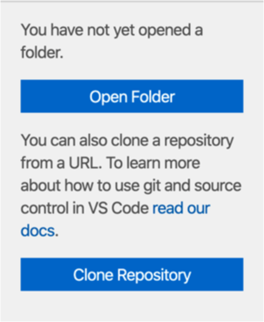

* Then choose the new folder from Step 1

Step 3: Install Live-Server Extension

* Click on **Extensions** on Left side-bar
* Search for “**live server**” (without double quote “)
* Choose Live Server from the list and click **Install**

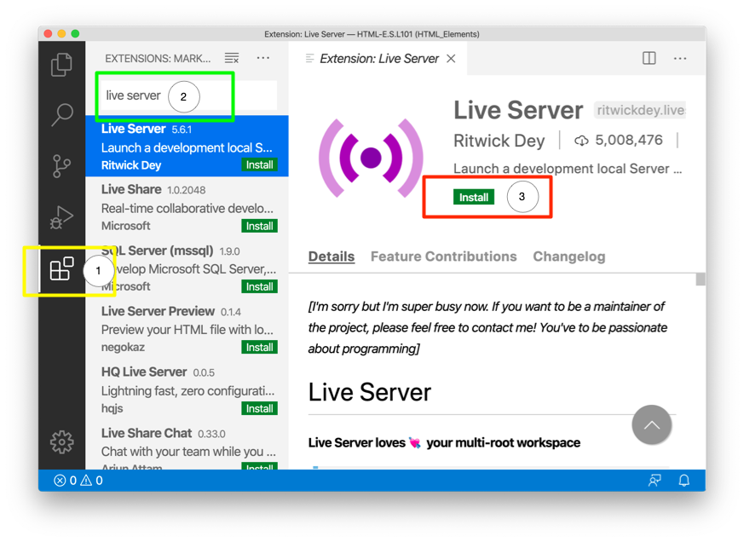

Step 4: Create index.html

* Click on Explorer tab on left side-bar
* Click on New file icon to create new file
* Enter **index.html** as new file name

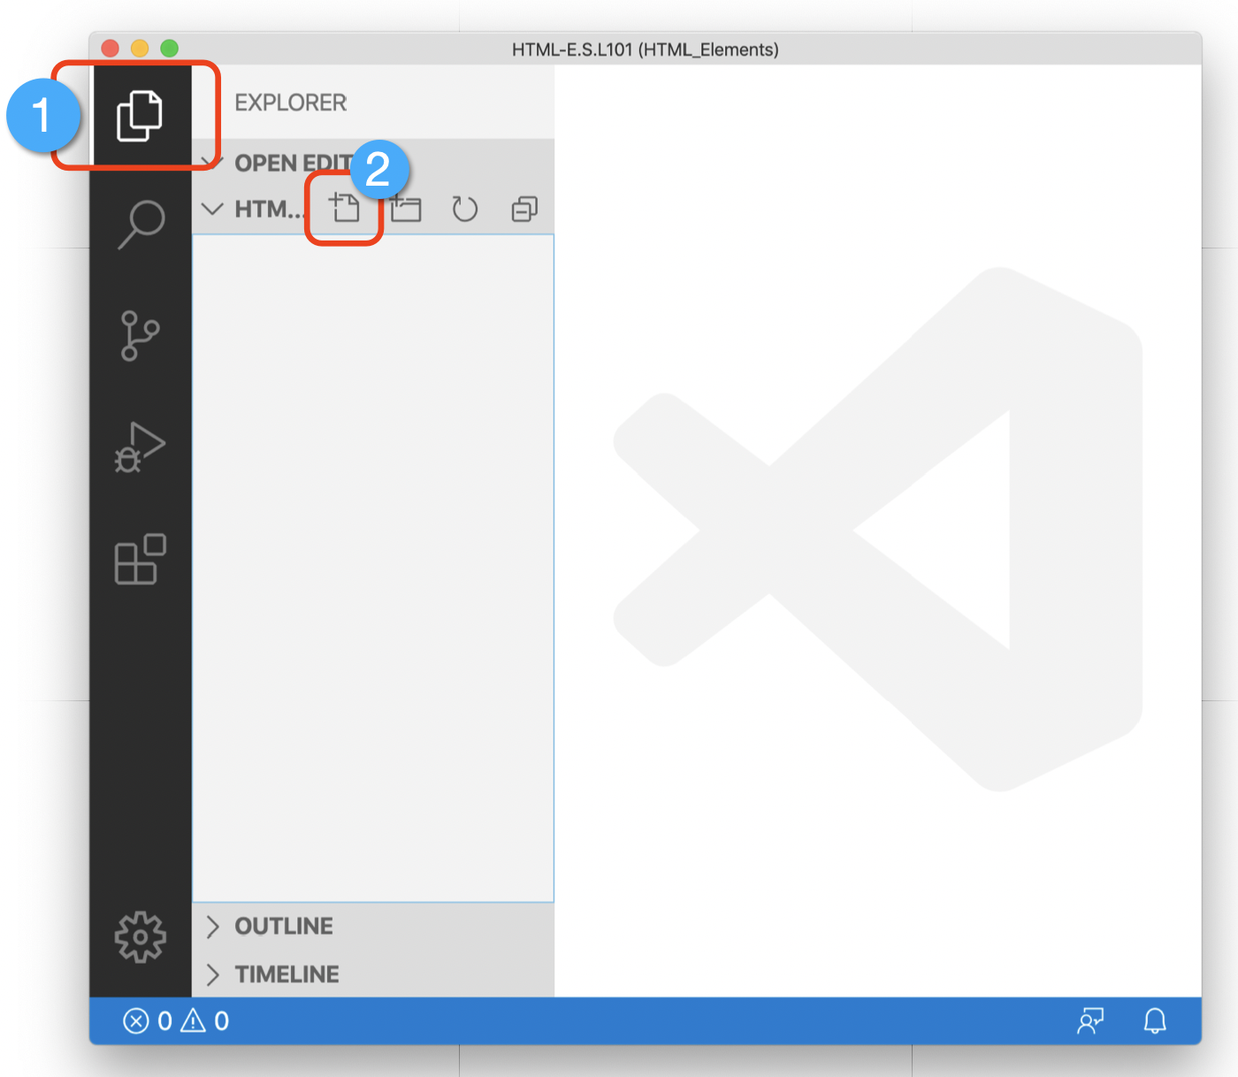

Step 5: Add your first HTML element

* Open **index.html** file
* Add content to the file: <h1>Hello Fresher</h1>
* Right click on index.html file and choose Open with Live Server
* You should be redirected to <http://127.0.0.1:5500/index.html>
* Verify the content in your Browsers

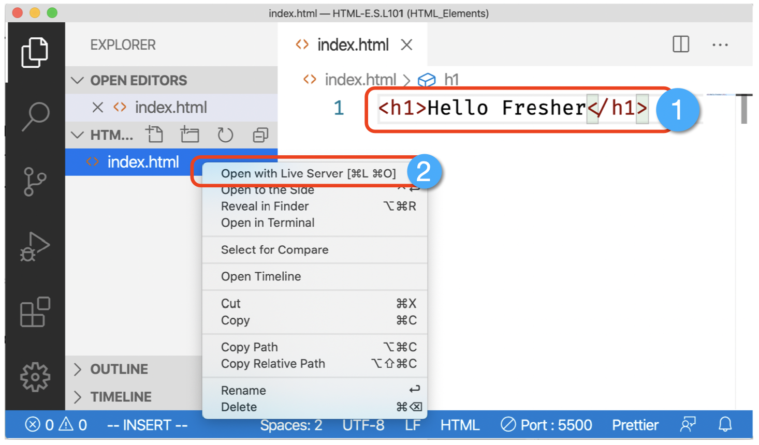

Step 6: Add attributes to HTML element

Another example of an element is [<a>](https://developer.mozilla.org/en-US/docs/Web/HTML/Element/a) — this stands for "anchor" and will make the piece of text it wraps around into a hyperlink. This can take a number of attributes, but several are as follows:

* **href**: This attribute's value specifies the web address that you want the link to point to; where the browser navigates to when the link is clicked. For example, href="https://www.mozilla.org/".
* **title**: The title attribute specifies extra information about the link, such as what page is being linked to. For example, title="The Mozilla homepage". This will appear as a tooltip when the element is hovered over.
* **target**: The target attribute specifies the browsing context that will be used to display the link. For example, target="_blank" will display the link in a new tab. If you want to display the link in the current tab, just omit this attribute.

Edit the line below in the *Input* area to turn it into a link to your favorite website.

1. First, add the <a> element.
2. Second, add the href attribute and the title attribute.
3. Lastly, specify the target attribute to open the link in the new tab.

You'll be able to see your changes update live in the *Output* area. You should see a link that when hovered over displays the value of the title attribute, and when clicked, navigates to the web address in the href attribute. Remember that you need to include a space between the element name, and each attribute.

Start:

1. <p>A link to my favorite website.</p>

End:

1. <p>A link to my <a href="https://www.mozilla.org/" title="The Mozilla homepage" target="_blank">favorite website</a>.</p>

Step 7: Adding some features to an HTML document

So in this exercise, you can edit the code locally on your computer, as outlined above, or you can edit it in the editable sample window below (the editable sample window represents just the contents of the [<body>](https://developer.mozilla.org/en-US/docs/Web/HTML/Element/body) element, in this case). We'd like you to have a go at implementing the following tasks:

* Just below the opening tag of the [<body>](https://developer.mozilla.org/en-US/docs/Web/HTML/Element/body) element, add a main title for the document. This should be wrapped inside an <h1> opening tag and </h1> closing tag.
* Edit the paragraph content to include some text about something you are interested in.
* Make any important words stand out in bold by wrapping them inside a <strong> opening tag and </strong> closing tag.
* Add a link to your paragraph, as [explained earlier in the article](https://developer.mozilla.org/en-US/Learn/HTML/Introduction_to_HTML/Getting_started#Active_learning_Adding_attributes_to_an_element).
* Add an image to your document, below the paragraph, as [explained earlier in the article](https://developer.mozilla.org/en-US/Learn/HTML/Introduction_to_HTML/Getting_started#Empty_elements). You'll get bonus points if you manage to link to a different image (either locally on your computer, or somewhere else on the web).

Start:

1. <p>This is my page</p>

End:

1. <h1>Some music</h1>
2. <p>
3. I really enjoy <strong>playing the drums</strong>. One of my favorite drummers
4. is Neal Peart, who plays in the band
5. <a
6. href="https://en.wikipedia.org/wiki/Rush_%28band%29"
7. title="Rush Wikipedia article"
8. >Rush</a
9. >. My favourite Rush album is currently
10. <a href="http://www.deezer.com/album/942295">Moving Pictures</a>.
11. </p>
12. <img
13. src="http://www.cygnus-x1.net/links/rush/images/albums/sectors/sector2-movingpictures-cover-s.jpg"
14. />

Step 8: Experiment with character encoding

**Sử dụng unicode để thêm các icon**

To try this out, revisit the simple HTML template you obtained in the previous section on <title> (the [title-example.html page](https://github.com/mdn/learning-area/blob/master/html/introduction-to-html/the-html-head/title-example.html)), try changing the meta charset value to ISO-8859-1, and add the Japanese to your page. This is the code we used:

1. <p>Japanese example: ご飯が熱い。</p>

Step 9: The description's use in search engines

* The description is also used on search engine result pages. Let's go through an exercise to explore this

1. Go to the [front page of The Mozilla Developer Network](https://developer.mozilla.org/en-US/).
2. View the page's source (Right/**Ctrl** + click on the page, choose *View Page Source* from the context menu.)
3. Find the description meta tag. It will look something like this (although it may change over time):
4. <meta name="description" content="The MDN Web Docs site
5. provides information about Open Web technologies
6. including HTML, CSS, and APIs for both Web sites and

progressive web apps.">

1. Now search for "MDN Web Docs" in your favorite search engine (We used Google.) You'll notice the description <meta> and <title> element content used in the search result — definitely worth having!

* 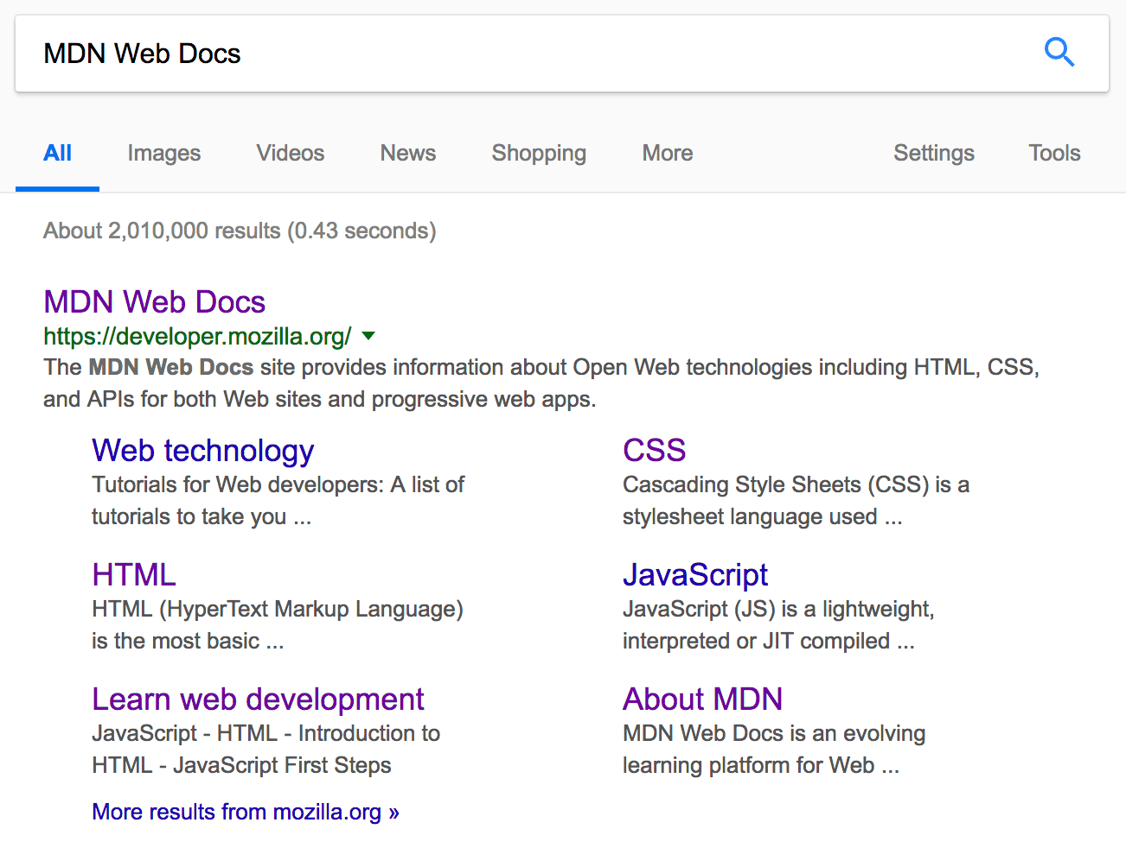
* **Note**: In Google, you will see some relevant subpages of MDN Web Docs listed below the main homepage link — these are called sitelinks, and are configurable in [Google's webmaster tools](http://www.google.com/webmasters/tools/) — a way to make your site's search results better in the Google search engine.
* **Note**: Many <meta> features just aren't used any more. For example, the keyword <meta> element (<meta name="keywords" content="fill, in, your, keywords, here">) — which is supposed to provide keywords for search engines to determine relevance of that page for different search terms — is ignored by search engines, because spammers were just filling the keyword list with hundreds of keywords, biasing results.

Step 10: Verify output

**-- THE END --**